**M2 Questions**

**Q. JENKINS-DOCKER**

**Question: Configure Jenkins to deploy a Docker container running Nginx to a local Docker host. The pipeline should build the Docker image and start the container.**

1. Pull the Jenkins image from the docker hub : docker pull Jenkins/jenkins

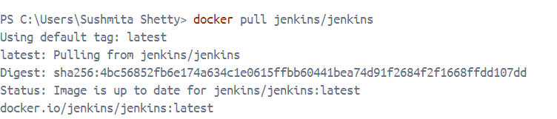

1. Run it :

docker run -d -p 8080:8080 -p 50000:50000 --name Jenkins -v jenkins_home:/var/jenkins_home jenkins/jenkins:lts

1. docker ps

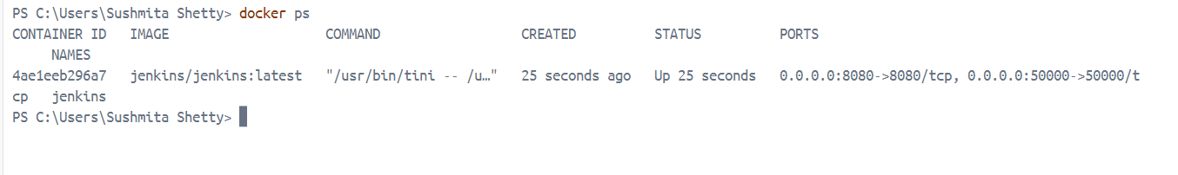

1. go inside the container : docker exec -u root -it Jenkins bash

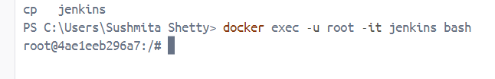

1. apt-get update

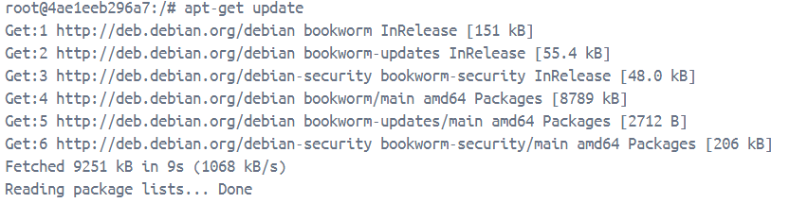

1. apt-get install -y docker.io

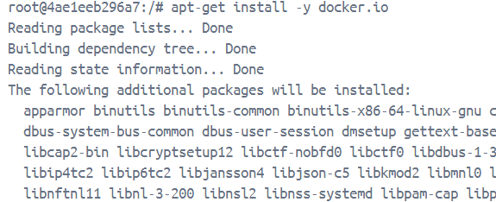

1. docker –version

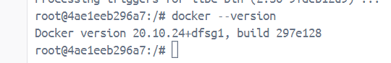

1. **Go to Jenkins->Manage Jenkins->Plug-ins->Docker commons->Install->Sign-in again->Check if installed successfully**

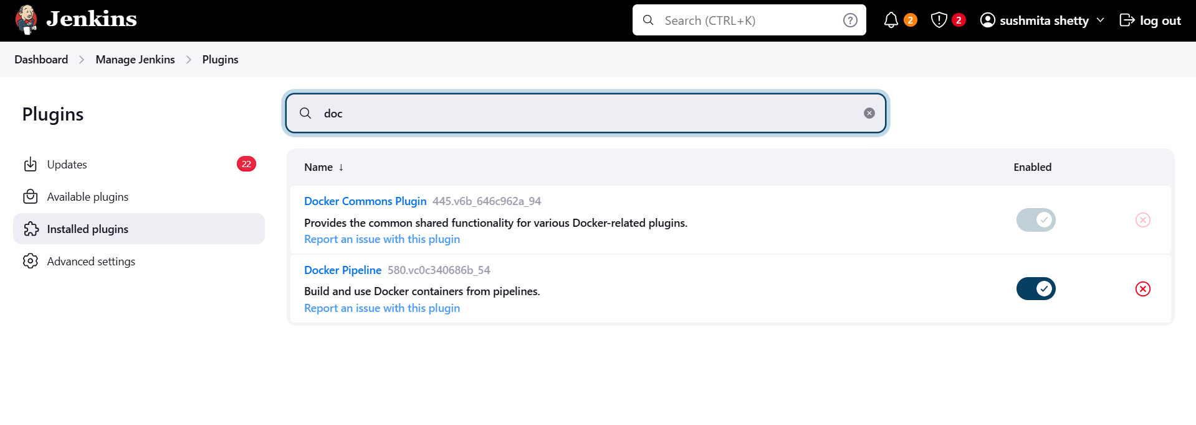

1. **Create a new folder:**
2. **Open it in VS code->**
3. **Dockerfile should be in Jenkins-Docker-Ngnix**
4. **Inside The Jenkins-Docker-Ngnix->Create a html folder-> Create your index.html inside the html folder:**

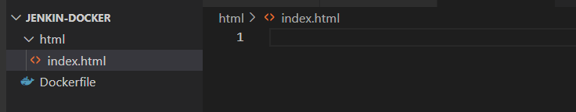

1. Content of docker fiel:

# Use the official Nginx image from the Docker Hub

FROM nginx:latest

# Copy custom Nginx configuration file (optional)

# COPY nginx.conf /etc/nginx/nginx.conf

# Copy HTML files or your web app into the container

# Make sure you have an 'index.html' or other web content to serve

COPY ./html /usr/share/nginx/html

# Expose port 80 for web traffic

EXPOSE 80

# Start Nginx in the foreground

CMD ["nginx", "-g", "daemon off;"]

1. Content of html file:

<!DOCTYPE html>

<html lang="en">

<head>

    <meta charset="UTF-8">

    <meta name="viewport" content="width=device-width, initial-scale=1.0">

    <title>Document</title>

</head>

<body>

    <h1>Hello World</h1>

</body>

</html>

1. **Push the project to git hub:**

**Open cmd go to that folder**



1. Do git init

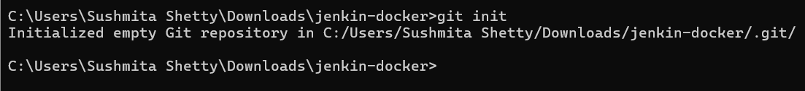

1. Git add .



1. 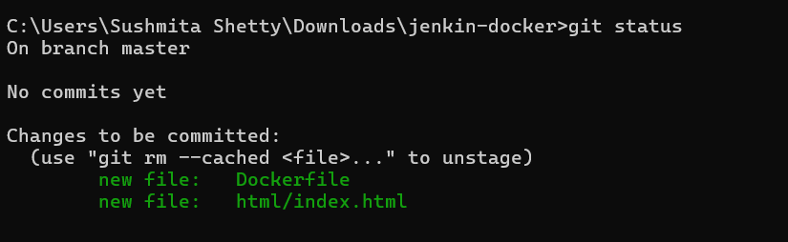
2. Git commit
3. 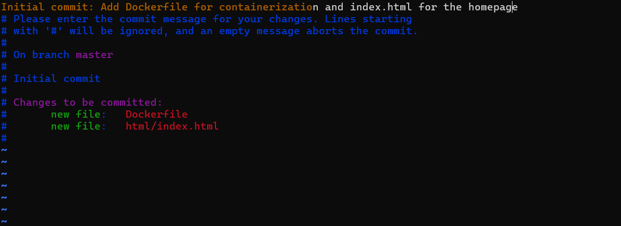
4. Esc :wq

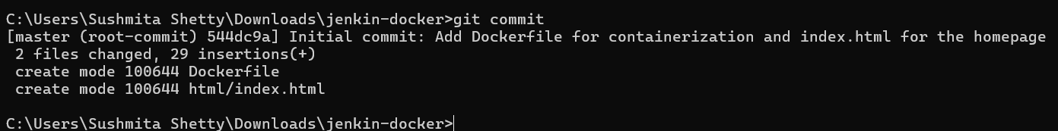

1. Create a repo
2. Cmd: git remote add origin https://github.com/sushmitashetty-19/docker-jenkins.git



1. Git remote -v

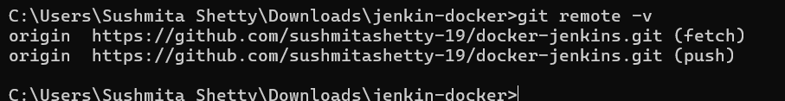

1. Git branch

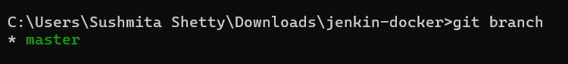

1. Git push -u origin master

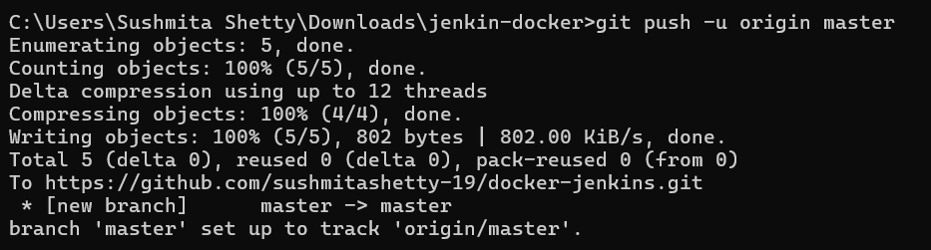

1. Check repo

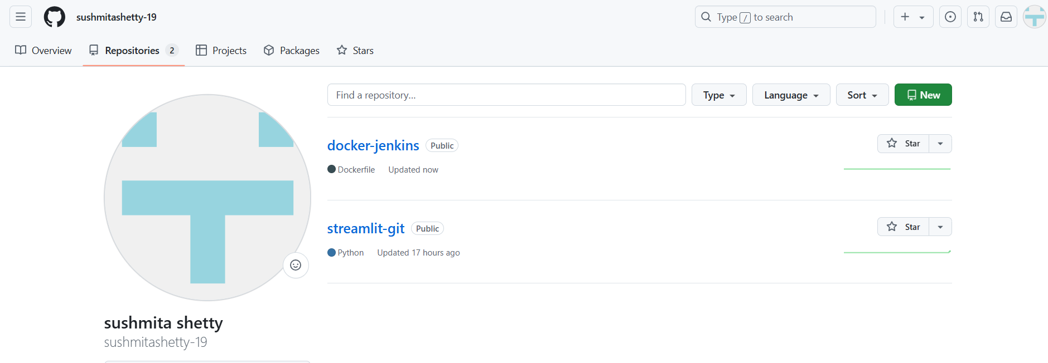

1. Now create jenkin pipeline and add:

pipeline {

agent any

stages {

stage('Clone Repository') {

steps {

// Example: clone your repository that contains your Dockerfile

git 'https://github.com/dakshita-thakkar/Jenkins-Docker-Nginx.git'

}

}

stage('Build Docker Image') {

steps {

script {

// Build the Docker image using the Dockerfile in your repository

sh 'docker build -t my-nginx-image .'

}

}

}

stage('Run Docker Container') {

steps {

script {

// Stop and remove any previous containers

sh 'docker ps -aq --filter "name=my-nginx-container" | xargs -r docker stop | xargs -r docker rm'

// Run the new container

sh 'docker run -d --name my-nginx-container -p 8081:80 my-nginx-image'

}

}

}

}

}